CS 142 Advanced Web Design

Preston Libby, Jasper Davis

Assignment 7, Final Project: Snag Social Media Website

Snag Social Media Website

Version <1.0>

Table Of Contents

Time Log 3

Introduction 4

Purpose 4

Definitions, acronyms, and abbreviations 4

Overall Description 4

Story Board 5

Assignment requirements 6

Specific requirements 8

|  |  |  |  |
| --- | --- | --- | --- |
| Time Log | | | |
| Estimated time to complete assignment => | | | 15 Hours |
| Date | Time Spent  (in hours) | Description | Author |
| 4/24/15 | 0.5 | Initial Commit, Rough List of Pages to Built Created | Preston Libby |
| 4/28/15 | 0.5 | Creation of Spec Sheet and Requirements | Preston Libby |
| 5/3/15 | 6 | PHP Backend | Jasper Davis |
| 5/3/15 | 4 | CSS and Formatting | Preston Libby |
| 5/3/15 | 3 | Usability Testing | Preston Libby + Jasper Davis |
|  |  |  |  |
|  |  |  |  |
|  |  |  |  |
|  |  |  |  |
|  |  |  |  |
|  |  |  |  |
|  |  |  |  |
|  |  |  |  |
|  |  |  |  |
|  |  |  |  |
|  |  |  |  |
|  |  |  |  |
|  |  |  |  |
|  | 14 | <=Total Time Spent |  |
|  |  |  |  |

# Introduction

### Purpose

The purpose of this document is to describe the requirement specification for the web site “Snag Social Media”.

The intended audience for this document is two fold. First it is the contract between you and the client and the developer of the site. Two primary goals are:

1. Client gets a very good understanding of what you will be delivering.
2. Developer has a very good understanding of what they are going to create.

The web site to be created is an informative site designed to be provide users with information on ways that they can help to make the world a better place. I believe that working to improve always begins with yourself. The collective whole of each individual can really make a difference.

### Definitions, acronyms, and abbreviations

HTML – Hypertext markup language – used to define your content.

PHP – Personal Home Page – language that helps to customize html.

CSS – Cascading Style Sheets – used to define the look of a web site.

W3 Validation – refers to both Html and CSS validation tool provided by the W3c.org. the html validator is located at:

<http://validator.w3.org/>

with the CSS validator located at:

<http://jigsaw.w3.org/css-validator/>

# Overall Description

This will be a social media site, currently named Snag, that will be aimed primarily at the audience of UVM first year students who want to participate in events created by fellow students. Currently, there exists a Facebook app that had a similar goal, but does not see widespread use. Students will be able to choose/create tags that represent activities they would like to attend/participate in. They will then see an active list of events related to these tags, and be able to create events they are hosting. The overall view and usage of the site will be as simple and minimalistic as possible while retaining full functionality and utility.

# Story Board

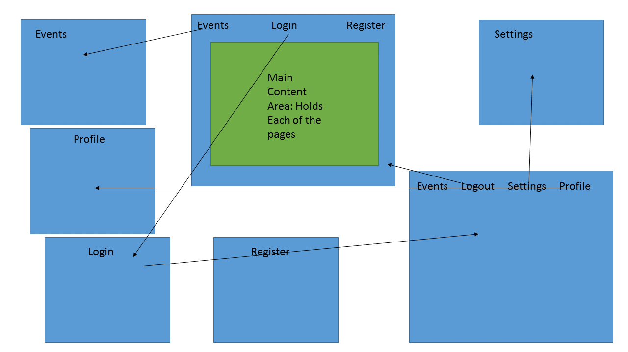

# Assignment requirements

The final project can be done in a group of 1,2 or 3 people. Notify me by April 11th whom your group partners are going to be. It is a fairly open ended project to allow for creativity. Keep in mind if you do the minimum then you get a minimum grade. You need to create a web site not a bunch of web pages.

Consider entering your project in the [CS Fair](http://www.uvm.edu/~csfair/2014) being held in Dec.

1. 40% General Items

* Create a complete and functional web site of your choice (minimum 5 pages) incorporating the concepts learned in this class.
* Create a [Project Specification Document](https://rerickso.w3.uvm.edu/education/blackboard/2015_Spring/cs142/assignments/Final.docx) and be sure to post a PDF of this document to be graded. be sure to include:

1. Cover page
2. Time log
3. Table of contents
4. Introduction
5. Purpose
6. Scope
7. Definitions, acronyms, and abbreviations
8. Overview
9. Overall Description
10. Story Board
11. Assignment requirements
12. Specific requirements
13. Bring one printed copy to the presentation

* Create an tool bar icon to be displayed along with your website (notice the deer?).
* One page description of why you chose the styles that you did and explain what extra features etc you have done. Think of this as a guide for the grader.
* Site Will pass W3 html 5 validation
* Other items as needed

1. 30% CSS

* Site Will pass W3 CSS 3 validation (screen)
* Site Will pass W3 CSS 3 validation (print)
* Quality of looks
* Quality of Code

1. 30% Web Usability

* Quality of documentation
* Quality of videos
* Minimum of two test subjects TIMES size of group so a group size of three will have a minimum of six tests.
* Minimum of two rounds of testing
* Each test should have good documentation (one pdf file for each) date of test, summary of changes you are making, detailed narrative, test results
* Can we see the before and after versions?

1. Quality of your peer grade ([criteria](https://rerickso.w3.uvm.edu/education/blackboard/peerGrade.php)). Peer grading needs to be completed in 48 hours from the due date.

# Specific requirements

1. ***Title for main page***: Snag – Get connected
2. ***Meta Description*:** Find events from fellow UVM students!
3. ***Meta Character set*:** UTF - 8
4. *Logo*: _______________
5. ***Content can be found here*:** <http://plibby.w3.uvm.edu/cs142assignment7/index.php>